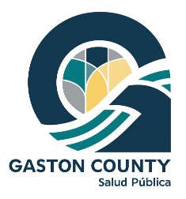
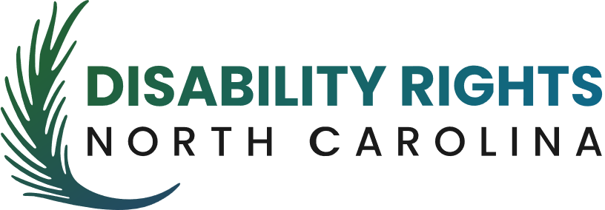

FOR IMMEDIATE RELEASE
August 29, 2022

FREE COMMUNITY FESTIVAL FEATURING A WALK & ROLL TO CONNECT LATINX FAMILIES WITH LOCAL BUSINESSES AND RESOURCES

GASTON COUNTY, N.C. – The Latinx Health Outreach Advisory Council is hosting a free community festival called “Caminemos y Rodemos Juntos Gaston / Gaston Walk and Roll Together.” The event will take place on Saturday, September 17, 2022 from 10:00am to 1:00pm in Gaston County, at the Rotary Centennial Pavilion (107 N. South St., Gastonia, NC 28052).

The festival is set to feature 40+ local vendors, live music, food trucks, children’s activities, free giveaways, and a 1.5 mile walk and roll to raise awareness about the amazing businesses and organizations who support our community. The walk and roll is wheelchair and stroller accessible, and will start promptly at 10:15am with activities set to follow. Attendees are encouraged to pre-register at eventbrite.com/e/gaston-walk-and-roll-together-tickets-400757194557 to receive up-to-date information as the event nears.

Disability Rights North Carolina (DRNC) and the Gaston County Department of Health and Human Services are taking lead as part of the Council’s initiative to connect community members with local resources to support safety, and the well-being of families in North Carolina. A few partners attending the event include Telemundo Charlotte, the City of Gastonia Police Department, Health Blue NC, and Latinos Aventureros en las Carolinas.

If you would like to learn more, or if you know a community-focused organization, business, or service provider who should join the event, more information can be found on the Facebook event page at: facebook.com/events/962627987772499/?active_tab=about.

###

Diana Willman
LatinX Outreach Coordinator | Gaston County Health and Human Services
Diana.willman@gastongov.com | 704-862-5406

